
A CAPSTONE PROJECT REPORT
Occupancy-Aware Smart Library Seat Reservation
with Predictive Demand Analytics
A Capstone Project Report submitted in partial fulfilment of the requirements
for the Course of
CSA0925-PROGRAMMIN IN JAVA
to the award of the degree of
BACHELOR OF TECHNOLOGY
IN
AIDS & AIML
Submitted by
E. LAKSHMI NARAYANAN (192524249)
L. JAYAKANAN(192525376)
Under the Supervision of
Dr .C. Sivasankar
Chennai – 602105
SEPTEMBER 2026

SIMATS ENGINEERING
Saveetha Institute of Medical and Technical Sciences
Chennai-602105

BONAFIDE CERTIFICATE
This is to certify that the Capstone Project entitled “Occupancy-Aware Smart Library Seat Reservation with Predictive Demand Analytics” has been carried out by E. Lakshmi Narayanan (Reg. No. 192524249) and L. Jayakannan(192525376) under the supervision of Dr .C .Sivasankar and is submitted in partial fulfilment of the requirements for the current semester of the B.Tech CSE at Saveetha Institute of Medical and Technical Sciences, Chennai.

COURSE COORDINATOR COURSE FACULTY
Dr. G. Charlyn Pushpa Latha Dr. C. Sivasankar
Professor Professor
Department of CSE Department of CSE
SIMATS Engineering SIMATS Engineering,
SIMATS, Chennai – 602105 SIMATS, Chennai – 602105.

SIMATS ENGINEERING
Saveetha Institute of Medical and Technical Sciences
Chennai-602105
DECLARATION
We, E. Lakshmi Narayanan and L. Jayakannan of the AI&DS ,AI%ML Department, SIMATS Engineering, Saveetha Institute of Medical and Technical Sciences, Chennai, hereby declare that the Capstone Project Work entitled “Occupancy-Aware Smart Library Seat Reservation with Predictive Demand Analytics” is the result of my own bonafide efforts. To the best of my knowledge, the work presented herein is original and has been carried out in accordance with engineering ethics and academic integrity. All sources, references, software, datasets and other materials used in the project have been appropriately acknowledged. I further declare that the data, results, analysis and findings presented in this report have not been fabricated, falsified or manipulated.
Any external tools, computational resources or AI-assisted tools used during the project have been used responsibly and verified by me. I confirm that the applicable academic, institutional and professional requirements have been followed throughout the planning, design, implementation, testing and documentation of the project.

Place: Chennai
Date: September 2026
Signature of the student
E. Lakshmi Narayanan (192524249)
L. Jayakannan(192525376)

INDIVIDUAL CONTRIBUTION STATEMENT
Students: E. Lakshmi Narayanan (192524249) and L. Jayakannan(192525376)
Table: Individual Contribution
Specific Responsibilities | Design & Development Contribution | Testing & Analysis Contribution | Report Contribution | Approx. Contribution (%)
Requirement analysis, system design, Java AWT interface, JDBC/MySQL integration, reservation workflow and predictive demand analysis | Contributed to requirement analysis, AWT interface design, database connectivity and reservation workflow implementation. | Contributed to validation of authentication, seat availability, reservation conflict handling and database operations. | Prepared project background, system design, pseudocode, testing documentation and report sections. | 50%
Database design, occupancy analysis, recommendation support, testing and documentation | Contributed to database structure, occupancy/demand analysis, recommendation logic and supporting implementation. | Contributed to test execution, result verification, edge-case checking and analysis of module outputs. | Prepared literature review, implementation/results sections and final documentation support. | 50%

ABSTRACT
University libraries often experience uneven seat demand, especially during peak study periods. Students may spend time searching for vacant seats, while some seats remain underused because availability and reservations are not coordinated. Manual seat allocation also provides limited information for predicting future demand. These issues create an engineering problem involving resource availability, time-based demand variation, reservation conflicts and efficient use of library space.
The proposed Occupancy-Aware Smart Library Seat Reservation with Predictive Demand Analytics is designed as a desktop-based smart reservation solution using Java AWT for the user interface, Java application logic for processing, JDBC for database connectivity and MySQL for persistent storage. The system allows users to view seat availability, reserve an appropriate seat, manage reservation periods and receive demand-oriented recommendations. Historical occupancy and reservation information are organized so that demand patterns can be analysed for different time periods and used to support future planning.
The development approach follows an iterative engineering process involving requirement identification, database and interface design, module implementation, validation and documentation. Major modules include authentication, seat management, reservation, occupancy tracking, predictive demand analysis, recommendation, user feedback and reporting. The design intentionally avoids dependence on physical IoT sensors so that the core system can be developed, tested and demonstrated using software-based records and historical data.
The expected engineering outcome is a practical library seat management system that improves visibility of seat availability, reduces reservation conflicts and provides decision support through historical demand analysis. The system also provides a foundation for later integration with real-time sensors, mobile interfaces and more advanced machine-learning models. Actual performance values and acceptance results should be inserted from the final project testing evidence before submission.
Keywords: Smart Library, Seat Reservation, Occupancy Analysis, Predictive Demand Analytics, Java AWT, MySQL
TABLE OF CONTENTS
S.No. | Content | Page No.
1 | CHAPTER 1 – INTRODUCTION AND ENGINEERING PROBLEM | 12
1.1 | Background | 12
1.2 | Need for the Project | 12
1.3 | Problem Statement | 12
1.4 | Project Aim | 13
1.5 | Project Objectives | 13
1.6 | Scope | 13
1.7 | Expected Engineering Outcome | 14
2 | CHAPTER 2 – LITERATURE REVIEW AND EXISTING SOLUTIONS | 15
2.1 | Review Method | 15
2.2 | Review of Existing Work | 15
2.3 | Comparative Analysis | 16
2.4 | Research / Engineering Gap | 16
2.5 | Proposed Contribution | 16
3 | CHAPTER 3 – ENGINEERING DESIGN, SUSTAINABILITY, ETHICS, SAFETY, RISK & SECURITY | 17
3.1 | Requirements | 17
3.2 | Constraints & Applicable Standards | 18
3.3 | Design Specifications | 18
3.4 | Alternative Solutions & Evaluation | 19
3.5 | Selected Design & Detailed Design | 19
3.6 | Trade-off Analysis | 20
3.7 | Sustainability, Ethics, Safety, Risk & Security | 20
4 | CHAPTER 4 – IMPLEMENTATION, TESTING & RESULTS, PROJECT MANAGEMENT | 22
4.1 | Development Approach & Resources | 22
4.2 | Hardware / Software / Fabrication Implementation & Modern Tools | 22
4.3 | Test Plan & Verification | 23
4.4 | Results | 23
4.5 | Data Analysis & Engineering Judgment | 24
4.6 | Comparison with Existing Solutions & Achievement of Objectives | 24
4.7 | Strengths & Limitations | 24
4.8 | Project Planning, Roles & Budget | 25
5 | CHAPTER 5 – CONCLUSION, FUTURE WORK AND REFLECTION | 27
5.1 | Conclusion | 27
5.2 | Future Work | 27
5.3 | Professional Learning & Individual Reflection | 27
6 | REFERENCES | 29
7 | APPENDICES | 30

LIST OF FIGURES
Figure No. | Figure Name | Page No.
Figure 1 | Overall System Architecture | 13
Figure 2 | System Workflow | 16
Figure 3 | Use Case Diagram | 21
Figure 4 | Database / ER Design | 22
Figure 5 | User Interface / Seat Reservation Screen | 29

LIST OF TABLES
Table No. | Table Name | Page No.
Table 1 | Comparative Analysis of Existing Approaches | 16
Table 2 | Stakeholder Requirements | 17
Table 3 | Functional and Non-Functional Requirements | 17
Table 4 | Applicable Standards and Practices | 18
Table 5 | Design Specifications | 18
Table 6 | Alternative Solution Evaluation | 19
Table 7 | Trade-off Analysis | 20
Table 8 | Sustainability, Ethics, Safety and Security Considerations | 20
Table 9 | Risk Register | 21
Table 10 | Development Resources | 22
Table 11 | Software and Tools Used | 22
Table 12 | Test Plan and Verification | 23
Table 13 | Objective Achievement | 24
Table 14 | Project Milestones | 25
Table 15 | Team / Individual Contribution | 25
Table 16 | Project Cost | 25

LIST OF ABBREVIATIONS / SYMBOLS
Symbol | Description | Unit
AWT | Abstract Window Toolkit | —
JDBC | Java Database Connectivity | —
DBMS | Database Management System | —
UI | User Interface | —
ML | Machine Learning | —
ER | Entity Relationship | —
UML | Unified Modeling Language | —
SQL | Structured Query Language | —
CRUD | Create, Read, Update, Delete | —
SDG | Sustainable Development Goal | —

CHAPTER 1
INTRODUCTION AND ENGINEERING PROBLEM

.Background
Academic libraries provide essential study space for students, researchers and faculty. During normal periods, students can usually locate seats without difficulty, but demand becomes uneven during examinations, assignment deadlines and other peak periods. A conventional approach depends on students physically checking available seats or relying on manual reservation procedures. This creates unnecessary movement, uncertain availability and inefficient use of limited study space.
An occupancy-aware digital reservation system can centralize seat information and provide a structured way to manage availability. When reservation history and occupancy records are retained, the same information can also be analysed to identify recurring demand patterns. This creates an opportunity to move from simple seat booking towards demand-aware planning and recommendation.

1.2 Need for the Project
The project is needed because library seating is a limited shared resource. Students are affected when they cannot quickly determine which seats are available or when reservations conflict with actual availability. Library administrators also need better information about busy periods, underused areas and recurring demand. From an engineering perspective, the problem combines user interaction, resource-state management, time-based reservation constraints, persistent data storage and predictive analysis.

1.3 Problem Statement
The engineering problem is to design and implement a software-based smart library seat reservation system that maintains seat availability, validates reservations, records occupancy-related information and analyses historical demand to support better seat allocation and library planning. The system must provide a usable interface, consistent database state, conflict-aware reservation processing and an extensible prediction mechanism without requiring physical IoT infrastructure for the core implementation.

1.4 Project Aim
To develop an occupancy-aware smart library seat reservation system that combines digital seat booking with predictive demand analytics to improve seat visibility, reservation management and utilization planning.

1.5 Project Objectives
• To design a user-friendly Java AWT interface for library seat management and reservation.
• To develop a database-backed mechanism for maintaining users, seats, reservations and occupancy records.
• To implement reservation validation that checks seat availability and prevents conflicting bookings.
• To analyse historical occupancy and reservation data to identify time-based demand patterns.
• To implement a demand-oriented recommendation function that assists users in selecting suitable seats or periods.
• To test the major system functions and validate their behaviour against defined requirements.

1.6 Scope
The project includes user authentication, seat and zone management, seat availability display, reservation creation and validation, occupancy record handling, historical demand analysis, recommendation, reporting and database persistence. The core implementation is software based and can be demonstrated without physical occupancy sensors.
The project excludes hardware sensor deployment, biometric identification, payment processing, mobile application deployment and large-scale production infrastructure. These may be considered as future extensions. The prediction component is also treated as a decision-support feature; final prediction accuracy must be established from the project dataset and testing evidence rather than assumed.

1.7 Expected Engineering Outcome
The expected outcome is a working desktop application that provides a structured workflow from authentication to seat discovery, reservation and demand analysis. The system should maintain consistent seat and reservation states in the database and produce understandable demand summaries that can support both student decisions and library management planning.
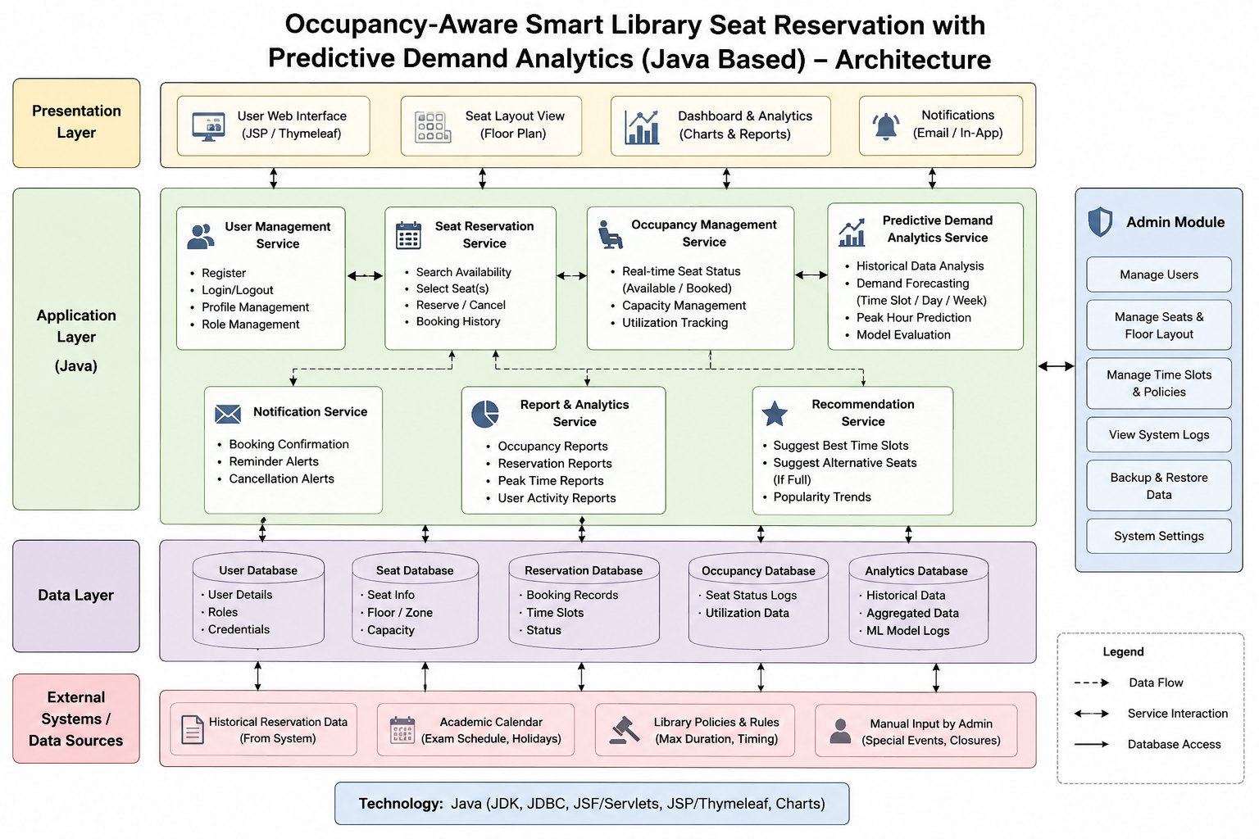
Figure 1:Systeem Architecture

CHAPTER 2
LITERATURE REVIEW AND EXISTING SOLUTIONS

2.1 Review Method
The review considered research on smart library seat management, occupancy monitoring, digital reservation systems and data-driven prediction of seating behaviour. Sources were selected from technical and academic publications that describe either software-based reservation approaches, occupancy monitoring systems or machine-learning analysis of library seating.

2.2 Review of Existing Work
Research on library seat management shows that seat allocation can be improved by making occupancy information visible and allowing users to reserve study spaces. Zhang, Bai and Fan described an intelligent library seat selection approach using sensors and QR-code-based information management to simplify seat selection and improve real-time awareness. Maepa and Moeti similarly investigated an IoT-based seat occupancy and reservation system using RFID and force-sensitive resistor technologies, demonstrating the feasibility of real-time seat monitoring.
Other smart-library research extends beyond seat reservation. Jayawardena et al. proposed an AI-based smart library management system that combines several library functions with intelligent recommendations and prediction-oriented components. A systematic review by Maepa and Moeti identified recurring challenges in smart library seat occupancy and reservation, including accurate occupancy information, reservation methods and estimation of reservation time.
More recent work has examined seat-level behaviour using machine-learning methods. A 2025 study based on long-term occupancy observations from an academic library analysed spatial, environmental and temporal attributes to understand seating preferences. The work demonstrates the value of historical occupancy data for predictive analysis, while also showing that human seating behaviour is complex and cannot be represented by a single simple factor.

2.3 Comparative Analysis
Table 1: Comparative Analysis of Existing Approaches
Existing Approach | Advantages | Limitations | Relevance to Proposed Work
Manual seat observation / first-come use | Simple and requires little technology | Poor visibility, time wastage and no historical analytics | Problem baseline
Sensor-based smart seating | Real-time occupancy awareness | Requires hardware deployment and maintenance | Useful future extension
Online seat reservation | Digital booking and improved visibility | May not provide demand prediction | Directly relevant
AI / ML smart library systems | Supports recommendations and prediction | Can be complex and data dependent | Supports predictive module
Proposed software-based system | Reservation + occupancy history + demand analytics without mandatory IoT | Prediction quality depends on available historical data | Target contribution

2.4 Research / Engineering Gap
Existing solutions frequently focus on either real-time occupancy sensing or reservation management, while predictive analysis may be treated as a separate capability. Sensor-based systems also introduce hardware cost and deployment dependencies. The identified gap is therefore a software-centred system that integrates reservation validation, occupancy history and demand-oriented analytics in one workflow while remaining implementable and testable without mandatory IoT hardware.

2.5 Proposed Contribution
The proposed project integrates seat reservation with historical occupancy and demand analysis. Instead of treating booking as an isolated transaction, the system maintains records that can be used to identify peak periods and support recommendations. The architecture also separates the interface, application logic and database so that a more advanced machine-learning model or real-time sensor source can be incorporated later without redesigning the complete system.

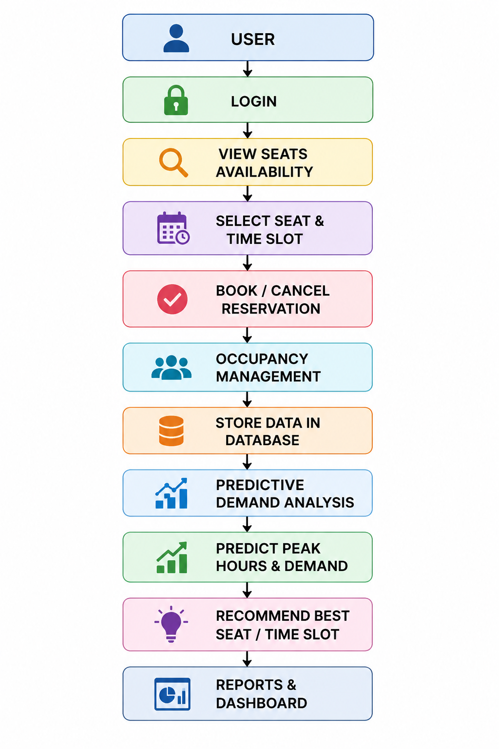
Figure 2:System Flow

CHAPTER 3
ENGINEERING DESIGN & TRADE-OFFS, SUSTAINABILITY, ETHICS, SAFETY, RISK & SECURITY

3.1 Requirements
Stakeholder / User Requirements
Table 2: Stakeholder Requirements
Stakeholder | Requirement
Student / Library User | View available seats, select a suitable seat and make or cancel a reservation.
Library Administrator | Manage seats, zones, users and reservation records.
Library Management | View occupancy and demand summaries for planning.
Project Administrator / Developer | Maintain database, configuration and system reliability.

Functional & Non-Functional Requirements
Table 3: Functional and Non-Functional Requirements
Requirement Type | Requirement | Measurable Target
Functional | User authentication | Valid users can access the dashboard; invalid credentials are rejected.
Functional | Seat availability | Current stored seat status is displayed correctly.
Functional | Reservation | Available seats can be reserved for a valid period.
Functional | Conflict validation | Overlapping reservation for the same seat is rejected.
Functional | Demand analytics | Historical records can be grouped by relevant time periods.
Functional | Recommendation | The system can produce a demand-aware seat/time recommendation.
Non-Functional | Usability | Common operations should be understandable through the AWT interface.
Non-Functional | Reliability | Database operations should preserve consistent reservation and seat states.
Non-Functional | Security | User-supplied database values should be handled using parameterized queries.
Non-Functional | Maintainability | UI, application logic and database access should remain separable.

3.2 Constraints & Applicable Standards
The system is constrained by the selected Java AWT desktop environment, MySQL database availability, JDBC connectivity, limited project development time and the absence of mandatory physical occupancy sensors. The design follows general software engineering and secure database practices. IEEE-style citation and documentation conventions are used for the report. Security implementation focuses on authentication, input validation and parameterized database operations rather than unsupported claims of complete security.
Table 4: Applicable Standards and Practices
Standard / Practice | Requirement | How Applied in This Project
IEEE referencing convention | Consistent citation of technical literature | Used for literature and reference formatting.
SQL/JDBC secure query practice | Avoid unsafe string concatenation for user input | PreparedStatement is used for parameterized operations.
UML modelling convention | Represent system structure and interactions clearly | Use case, class, activity and architecture diagrams are planned for the design chapter.

3.3 Design Specifications
Table 5: Design Specifications
Parameter | Target / Requirement | Unit | Priority
GUI technology | Java AWT only | Technology | High
Database | MySQL | Technology | High
Connectivity | JDBC / MySQL Connector | Technology | High
Reservation conflict | No overlapping confirmed booking for same seat | Condition | High
Occupancy data | Store time-associated occupancy information | Record | High
Demand analysis | Group historical demand by time/period | Analysis | High
Authentication | Validate user credentials before dashboard access | Condition | High

3.4 Alternative Solutions & Evaluation
Alternative 1: Sensor-based smart library. This approach uses physical occupancy sensors and a network layer to obtain real-time seat status. It offers strong real-time visibility but increases hardware, deployment and maintenance requirements.
Alternative 2: Software-only reservation and analytics. This approach stores seat, reservation and occupancy information in a database and performs analysis through the application. It is easier to develop and demonstrate within the project constraints.
Alternative 3: Web/mobile-first system. This approach provides broader device access but requires additional web/mobile technologies and deployment infrastructure beyond the core Java AWT scope.
Table 6: Alternative Solution Evaluation
Criterion | Weight | Alternative 1: Sensor | Alternative 2: Software | Alternative 3: Web/Mobile
Performance / real-time awareness | High | High | Medium | High
Cost / project feasibility | High | Low | High | Medium
Safety / deployment simplicity | Medium | Medium | High | High
Sustainability / maintenance | Medium | Medium | High | Medium
Reliability of stored records | High | High | High | High

3.5 Selected Design & Detailed Design
The software-based architecture is selected because it satisfies the project objective while remaining feasible without physical sensor infrastructure. The system is organized into presentation, application and persistence layers. AWT screens collect user actions; Java business logic validates reservations and computes demand-related information; JDBC transfers operations to MySQL; and stored records provide the basis for occupancy and demand analysis.
System interface flow: User → AWT Interface → Validation / Business Logic → JDBC → MySQL → Result → AWT Output.
The major subsystem interfaces are: authentication with user records; seat management with seat/zone records; reservation with seat and time constraints; occupancy analytics with historical records; recommendation with demand analysis; and reporting with aggregated database queries.
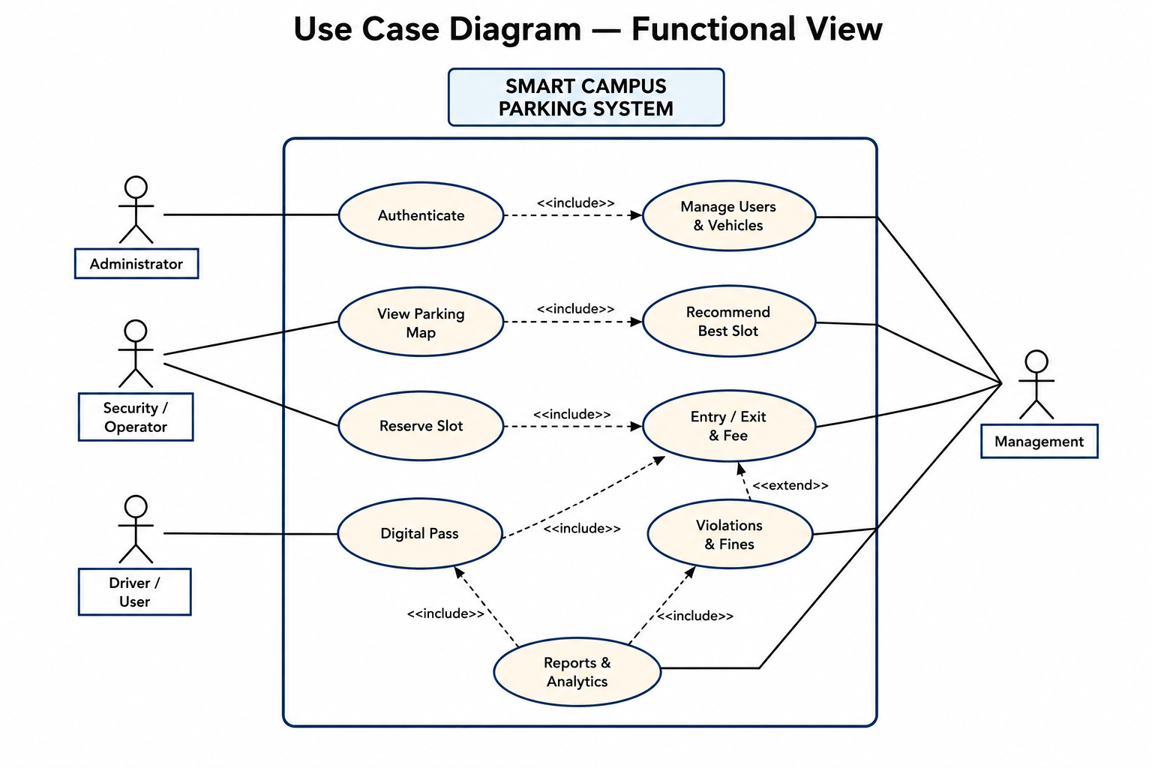
Figure 3:Case Diagram

3.6 Trade-off Analysis
Table 7: Trade-off Analysis
Design Decision | Alternative Considered | Benefit | Disadvantage | Final Decision & Justification
Java AWT interface | Swing / web UI | Matches project GUI requirement and native Java environment | Less modern than web UI | Selected because the implementation is intended for Java AWT.
MySQL persistence | File-based storage | Structured queries and reliable relational records | Requires DB setup | Selected for relational reservation and occupancy data.
Software occupancy records | Mandatory IoT sensors | Lower deployment cost and simpler testing | Not truly real-time without an external feed | Selected for the project scope; sensor integration is future work.
Historical demand baseline | Complex ML-only solution | Easy to validate and explain | May not capture complex behaviour | Selected as an extensible baseline; advanced ML can be added later.

3.7 Sustainability, Ethics, Safety, Risk & Security
Table 8: Sustainability, Ethics, Safety and Security Considerations
Domain | Consideration | Evidence Evaluated | Impact on Final Decision
Sustainability | Avoid unnecessary hardware for core prototype | Project scope and available development resources | Software-first design reduces deployment dependencies.
Ethics | Avoid exposing unnecessary student information | Authentication and database access requirements | Only required user data should be stored and displayed.
Health & Safety | Reduce unnecessary movement while searching for seats | Problem context and reservation workflow | Digital availability reduces repeated physical searching.
Security | Protect authentication and database operations | Parameterized JDBC queries and validation | Use validation and restricted access to database functions.

Table 9: Risk Register
Risk | Likelihood | Severity | Risk Level | Mitigation | Residual Risk
Incorrect reservation conflict logic | Medium | High | High | Validate time overlap before insertion and test conflict cases. | Low/Medium
Database connection failure | Medium | High | High | Handle exceptions, validate connection and display clear errors. | Medium
Insufficient historical data for prediction | Medium | Medium | Medium | Use a baseline analysis and clearly state data limitations. | Medium
Unauthorized account access | Medium | High | High | Authentication, validation and controlled database access. | Medium
Incorrect or stale occupancy records | Medium | Medium | Medium | Timestamp records and provide administrative correction/validation. | Medium

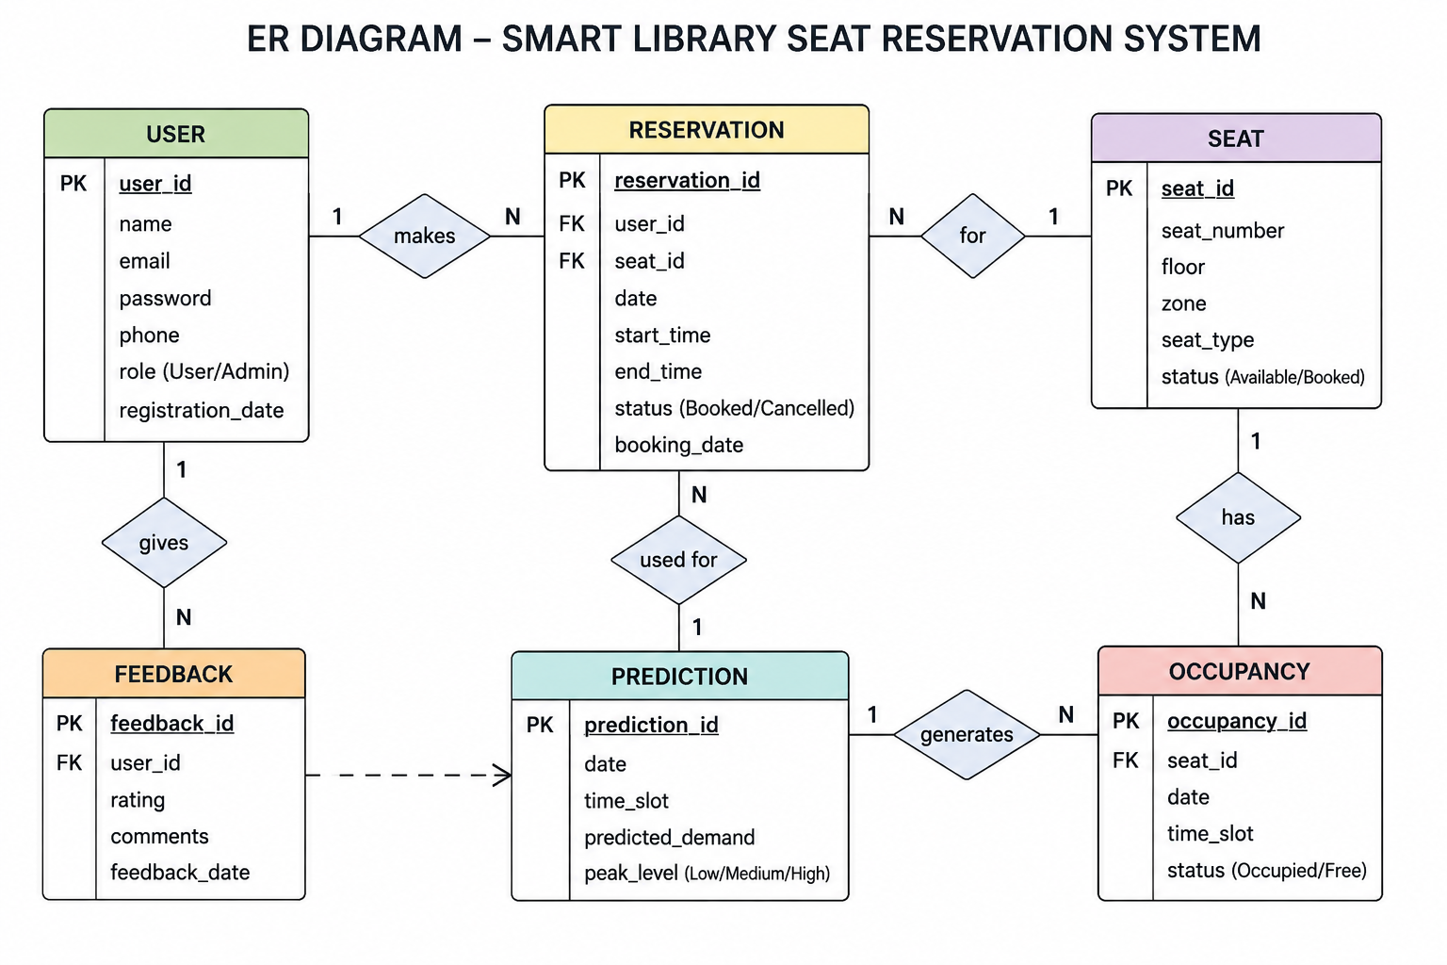
Figure 4:ER DIAGRAM

CHAPTER 4
IMPLEMENTATION, TESTING & RESULTS, PROJECT MANAGEMENT

4.1 Development Approach & Resources
An iterative development approach is suitable because the system contains several connected modules whose behaviour can be validated incrementally. The development sequence is requirements analysis, database design, AWT interface development, reservation and occupancy logic, demand analytics, integration, testing and documentation. Each major module can be tested independently before full-system integration.
Table 10: Development Resources
Resource | Purpose
Java JDK | Compilation and execution of the application
Eclipse IDE | Java project development and debugging
Java AWT | Desktop graphical user interface
MySQL Server | Persistent data storage
MySQL Workbench | Database creation, inspection and query testing
MySQL Connector/J | JDBC connectivity between Java and MySQL

4.2 Hardware / Software / Fabrication Implementation & Modern Tools Used
The project is software-based. No fabrication is required for the core implementation. The application is implemented as a Java AWT desktop system connected to MySQL through JDBC. The main implementation areas are authentication, seat and zone management, reservation, occupancy records, demand analytics, recommendation and reporting.
Table 11: Software and Tools Used
Tool / Software / Equipment | Purpose | Stage Used
Java | Application programming | Implementation
Java AWT | GUI construction and event handling | Front-end implementation
JDBC | Database connectivity | Back-end integration
MySQL | Relational database | Database implementation
MySQL Workbench | Database design and verification | Database testing
Eclipse IDE | Coding and debugging | Development
Git / GitHub | Version control and repository management | Documentation / submission

4.3 Test Plan & Verification
Table 12: Test Plan and Verification
Requirement | Test Method | Acceptance Criterion | Specification Required Value | Achieved Value | Status
Authentication | Enter valid and invalid credentials | Valid user reaches dashboard; invalid user is rejected | As defined | To be entered from actual test | To be entered
Seat availability | Open seat management/reservation view | Correct stored status is shown | As defined | To be entered from actual test | To be entered
Reservation | Book an available seat | Reservation record is created | As defined | To be entered from actual test | To be entered
Conflict validation | Book same seat with overlapping period | Conflicting booking is rejected | As defined | To be entered from actual test | To be entered
Demand analytics | Run demand report | Grouped demand summary is displayed | As defined | To be entered from actual test | To be entered
Recommendation | Request suitable seat/time | Recommendation is generated from available data | As defined | To be entered from actual test | To be entered
Database integration | Compare GUI action with MySQL record | Application and DB state agree | As defined | To be entered from actual test | To be entered

4.4 Results
The final results section must contain evidence from the implemented system. The expected functional evidence includes successful login, seat availability display, reservation confirmation, conflict rejection, occupancy/demand analysis and recommendation output. Numerical performance values, prediction accuracy and other measurements must be entered only after executing the corresponding tests on the final implementation.
Recommended evidence to insert: (1) Eclipse project structure, (2) login screen, (3) main dashboard, (4) seat map / availability screen, (5) reservation confirmation, (6) demand analytics output, (7) recommendation output, and (8) MySQL Workbench records.

4.5 Data Analysis & Engineering Judgment
The central engineering judgement is that historical seat-use data is useful only when it is recorded with sufficient context, such as date, time period, seat/zone and occupancy or reservation status. Aggregating these records can reveal recurring peak periods and relatively low-demand periods. However, predictions are dependent on data quality, sample size and changes in student behaviour. Therefore, the project should report actual model or baseline performance only after testing and should distinguish between observed historical demand and predicted demand.
If the observed results differ from the expected behaviour, possible causes include incomplete records, incorrect reservation timestamps, insufficient historical observations or unexpected user behaviour. These factors should be discussed with reference to the actual test evidence.

4.6 Comparison with Existing Solutions & Achievement of Objectives
Table 13: Objective Achievement
Objective | Evidence | Achievement
Design a Java AWT seat reservation interface | Implemented AWT screens and event handling | To be verified from final screenshot
Maintain seats, users and reservations in MySQL | Database schema and JDBC operations | To be verified from DB evidence
Prevent reservation conflicts | Conflict validation test case | To be verified from test result
Analyse historical occupancy/demand | Demand analytics module and report | To be verified from output
Provide demand-oriented recommendation | Recommendation module/output | To be verified from output
Test major functions | Test plan and executed results | To be verified from completed test table

4.7 Strengths & Limitations
Strengths:
• Integrates reservation and demand analysis in one workflow.
• Uses a relational database for persistent and traceable records.
• Can be developed and demonstrated without mandatory IoT hardware.
• Provides a clear path for future machine-learning and real-time occupancy extensions.
Limitations:
• Core occupancy status depends on software records unless an external real-time source is added.
• Prediction quality depends on the quantity and quality of historical data.
• Java AWT provides desktop access rather than a browser/mobile interface.
• Final performance and prediction metrics require evidence from actual project testing.

4.8 Project Planning, Roles & Budget
Table 14: Project Milestones
Milestone | Planned Activity | Expected Deliverable
1 | Requirement analysis | Problem definition and requirements
2 | System and database design | Architecture, UML and ER design
3 | AWT interface development | Working user interface
4 | Reservation and database integration | Core transaction workflow
5 | Occupancy and demand analytics | Analytics module
6 | Testing and debugging | Verified test cases
7 | Documentation and presentation | Final report and demonstration

Table 15: Team / Individual Contribution
Student | Assigned Responsibility | Actual Contribution
E. Lakshmi Narayanan | System design, Java AWT, database integration, reservation and analytics documentation | To be confirmed against final GitHub/project evidence

Table 16: Project Cost
Item | Estimated Cost | Actual Cost
Existing development computer | — | —
Java / Eclipse development tools | No additional project cost expected | —
MySQL / Workbench | No additional project cost expected | —
IoT hardware | Not required for core implementation | —

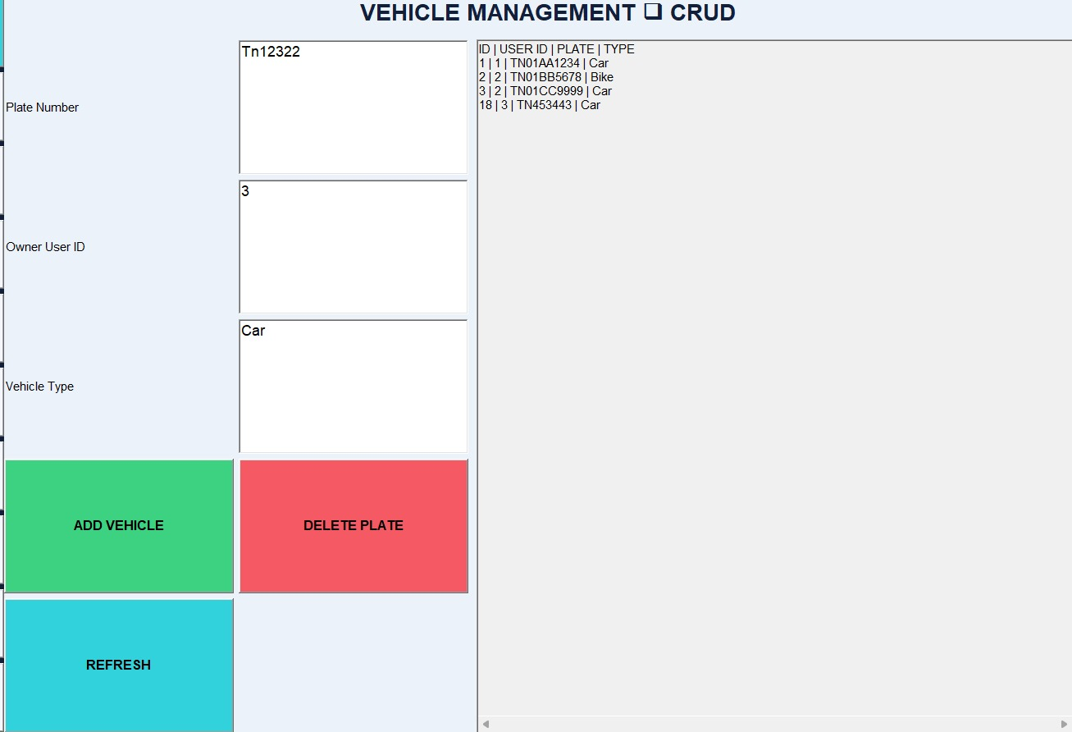
Figure 5:Interaction Interface

CHAPTER 5
CONCLUSION, FUTURE WORK AND REFLECTION

5.1 Conclusion
The Occupancy-Aware Smart Library Seat Reservation with Predictive Demand Analytics project addresses the practical problem of managing limited library study seats. The proposed solution combines digital reservation, seat availability management, historical occupancy information and demand-oriented analysis within a single software architecture. Java AWT provides the desktop interface, Java application logic handles validation and processing, JDBC provides database connectivity and MySQL maintains persistent records.
The engineering value of the project lies in connecting reservation management with analytical use of historical data rather than treating seat booking as an isolated transaction. The design also considers realistic constraints such as limited development resources, the need for reliable database state and the absence of mandatory IoT infrastructure. Final claims about performance, prediction accuracy and user acceptance should be based on the completed test evidence.

5.2 Future Work
• Integrate real-time occupancy sensors or other trusted occupancy sources.
• Develop a mobile or web interface for wider user access.
• Use advanced machine-learning models for time-based demand forecasting after sufficient data is collected.
• Add QR-based check-in and check-out to reduce unused reservations.
• Introduce automated notifications for reservation start, expiry and cancellation.
• Add richer dashboards for library management and long-term space planning.

5.3 Professional Learning & Individual Reflection
New Knowledge Acquired:
• Java AWT event-driven interface development
• JDBC and relational database integration
• Reservation conflict and state-management logic
• Occupancy data organization and demand analysis
• Software testing, documentation and system-level design
Engineering & Professional Skills Developed:
• Requirement analysis and technical documentation
• Database design and SQL problem solving
• Debugging and validation
• System decomposition and module integration
• Technical communication and project planning
Individual Reflection – E. Lakshmi Narayanan:
The most challenging part of the project was coordinating seat availability, reservation time ranges and database state so that a reservation could not create an inconsistent seat condition. I addressed this by separating validation from database operations and by considering conflict checks before confirming a reservation. A key engineering decision was to keep the core implementation software based rather than depending on physical sensors, which made the system easier to develop and test within the project scope. I also gained practical knowledge of connecting a Java AWT application to MySQL through JDBC and learned that predictive analysis must be supported by adequate historical data rather than assumed accuracy. If the project were repeated, I would collect a larger and more structured occupancy dataset and evaluate multiple prediction models before selecting the final approach.

REFERENCES
[1] Y. Zhang, Y. Bai and L. Fan, “Design of Intelligent Library Seat Selection System,” Journal of Simulation, vol. 7, no. 1, 2019.
[2] M. R. Maepa and M. N. Moeti, “IoT-Based Smart Library Seat Occupancy and Reservation System using RFID and FSR Technologies for South African Universities of Technology,” in Proceedings of icARTi, 2021, doi: 10.1145/3487923.3487933.
[3] C. Jayawardena, S. Reyal, K. R. Kekirideniya, G. H. T. Wijayawardhana, D. G. I. U. Rupasinghe and S. Y. R. M. Lakranda, “Artificial Intelligence Based Smart Library Management System,” 6th IEEE International Conference on Recent Advances and Innovations in Engineering (ICRAIE), 2021, doi: 10.1109/ICRAIE52900.2021.9703998.
[4] M. R. Maepa and M. N. Moeti, “A Systematic Review on IoT-Based Smart Technologies for Seat Occupancy and Reservation Needs in Smart Libraries at Institution of Higher Learning,” IntechOpen, 2023, doi: 10.5772/intechopen.113329.
[5] H. Altamirano et al., “From motion to meaning: understanding students’ seating preferences in libraries through PIR-enabled machine learning and explainable AI,” Frontiers in Psychology, 2025.
Note: Verify all bibliographic details against the final source copies before submission.

APPENDICES
Appendix A – Detailed Calculations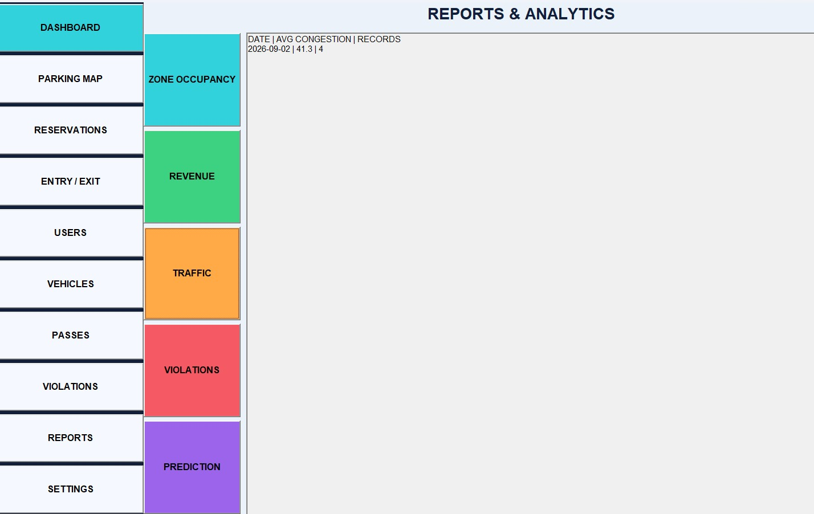

Appendix B – Engineering Drawings / Schematics



Appendix C – Code Repository Information
https://github.com/Jeyakannan-473/Smart-campus-parking-system---Java
https://github.com/Lakshminarayanan2211/LakshmiNarayanancsa0925
Appendix D – Project Meeting / Progress Records

Appendix H – User / Industry Feedback



Appendix J – Individual Contribution Evidence
